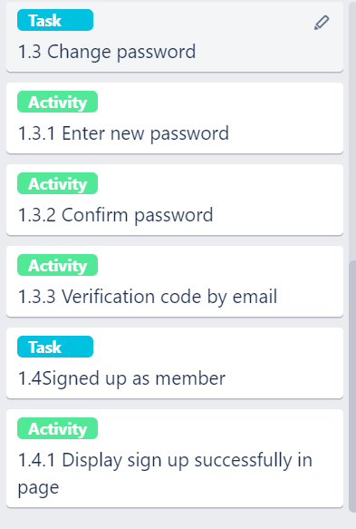

USER STORY 1:User A

User Stories: As a user, I wished that I want sign up as new member because I am new user in programming forum.

Goal:Sign up as a new member

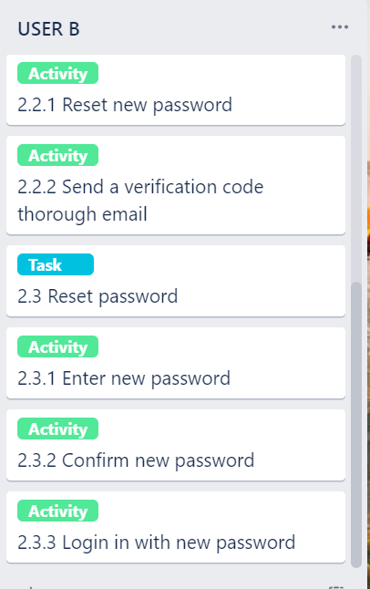

User Story 2: User B

-User stories: As user, I want to sign into my account for solving issues and increase my knowledge in the programming forum

-Goal: Sign account and able to reset password

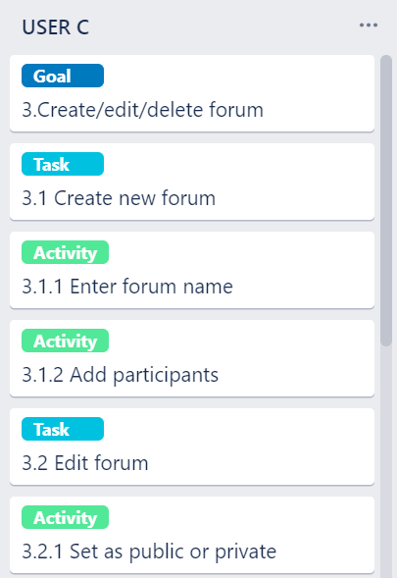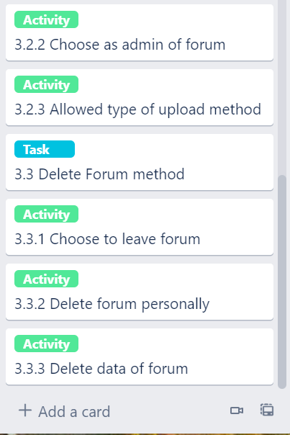

USER STORY 3: User C

User stories: As user, I wished that I am able to create/edit and delete the each forum for discussing and solving issues.

Goal:Create/edit and delete forum

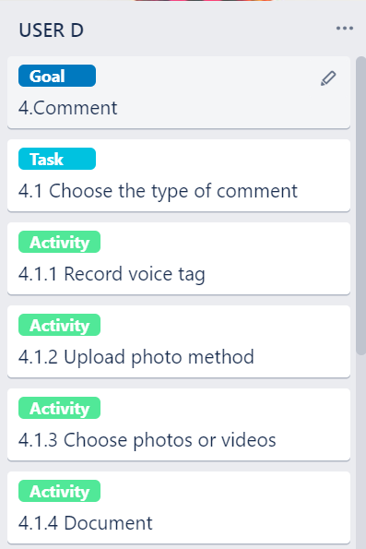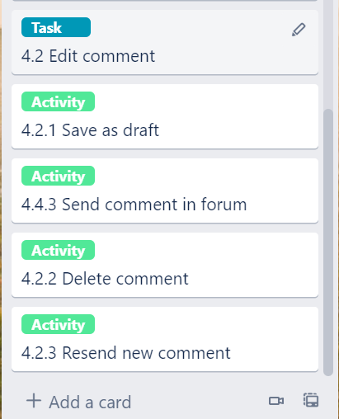

USER STORY 4:User D

User stories: As a user , I want to be able send comment with different type method and delete comment in a forum.

Goal:Give comment and able to delete comment